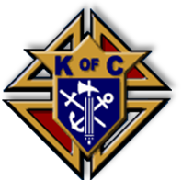

**Knights of Columbus Council**

**Saint John Neumann**

**Council #5971**

**6578 NW 13th Ct., Plantation, FL 33313**

**Volume 45 – November, 2013 – Issue # 11**

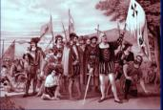

*Published Monthly for Knights of Columbus Members and their spouses.* [***www.knights-of-columbus--council-5971.com***](http://www.knights-of-columbus--council-5971.com)

**Message from the Grand Knight**

**Brothers!** October was another great month we had the Trunk or Treat at All Saints, lots of candy and fun. We had another successful Mondaynighter and Fridaynightner, special thanks to brother Gus for all his work in putting together the Fridaynightner. I would like to thanks all the brother Knights and sisters Colombiettes that help on the two weekend membership drive at All Saints and St. Bernard.

Brothers let’s get active, keep working hard promoting our Order, getting new members, participate on all the activities of the Council, join the 200 Club, come to the Mondaynightners and bring a friend to show them who we are.

***HAVE A BLESS THANKSGIVING DAY***

***WITH ALL YOUR LOVES ONES.*** Vivat Jesus!

Eduardo J. Kianes, GK

**OFFICERS AND DIRECTORS**

**Chaplain, Fr. Carlos E. Vega**

**954-741-7800,** [**stbernardoffice@gmail.com**](mailto:stbernardoffice@gmail.com)

**Grand Knight, Eduardo KIanes**

**954-804-8089,** [**kianes1@comcast.net**](mailto:kianes1@comcast.net)

**Deputy Grand Knight, Mark Salois**

**954-336-0352,** [**mrsalois@gmail.com**](mailto:mrsalois@gmail.com)

**Financial Secretary, Bill Grieco**

**954-741-6277,williamgrieco@bellsouth.net**

**Chancellor, Tony Spatola**

**954-260-8185,** [**anthonyspatola@bellsouth.net**](mailto:anthonyspatola@bellsouth.net)

**Warden, Donald Barnett**

**954-336-0352,** [**magician01@comcast.net**](mailto:magician01@comcast.net)

**Treasurer, Gus Hosbach**

**954-448-6962, myboss7@yahoo.com**

**Recorder, Richard Ortega**

**954-748-6573,** [**RLOrtega@aol.com**](mailto:RLOrtega@aol.com)

**Advocate, Gilbert S. Keaton**

**954-474-4089**

**Lecturer, David Espeut**

[**daveespeut@hotmail.com**](mailto:daveespeut@hotmail.com)

**Pro-Life Director, Camilo Rodriguez**

**954-90-1961,** [**camilowen@hotmail.com**](mailto:camilowen@hotmail.com)

**Insurance Agent, Danny Oscariz**

**305-807-4383,** [**danny.oscariz@kofc.org**](mailto:danny.oscariz@kofc.org)

**4th Degree, Dennis Sheridan**

**954-720-2439,** [**denniss5720@aol.com**](mailto:denniss5720@aol.com)

**200 Club Chairman, Mark Horsch**

**954-749-6639,** [**meHorsch@comcast.net**](mailto:meHorsch@comcast.net)

**District Deputy, Mitch Kraft**

**954-593-1952,** [**mitchkraft@bellsouth.net**](mailto:mitchkraft@bellsouth.net)

**Newsletter Editor, Eduardo Kianes**

**954-804-8089**, [**kianes1@comcast.net**](mailto:kianes1@comcast.net)

**1492 President, Rocco Cambareri**

**954-583-6645,** [**RCAMBAR@bellsouth.net**](mailto:RCAMBAR@bellsouth.net)

**1492 Vice President, Peter Becker**

**954-746-5436,** [**pblcasey@att.net**](mailto:pblcasey@att.net)

**11/01/13 All Saints Day**

**11/02/13 All Souls’ Day**

**11/03/13 Daylight savings time ends**

**11/04/13 Council Business Meeting,**

**Council Hall - 8:00PM**

**11/10/13 Veterans Appreciation**

**Mass & Dinner**

**St. Gregory Church – 3:00PM**

**11/11/13 Veterans' Day**

**11/11/13 Colombiettes Meeting,**

**Council Hall – 7:30PM**

**11/12/13 First & Second Degree**

**Ascension Church – 7:00PM**

**11/16/13 4th Degree, Officers Installation**

**Council Hall – 6:00PM**

**11/17/13 Grandma’s Attic/Flea Market**

**St. Bernard – 9:00AM**

**11/18/13 Mondnaynighters, Football**

**Game (Patriots at Panthers)**

**Council Hall - 8:00PM**

**11/21/13 4th Degree Meeting,**

**Council Hall - 8:00PM**

**11/28/13 Thanksgiving Day**

**Welcome Back Brothers!**

Dear Brother Knight, please try to attend a meeting. We need your ideas to help us grow and keep forward with the works of our council and order. Stay active in the council. If you have not made a meeting in some time, come-back and join your brothers, don’t worry about how long is been just show up we will love to see you again. Next council meeting is on November 4. See you there!

Mark Salois, DGK



Arthur Vincent, Peter K. Esquire

Richard Ortega, William G Benson,

Christopher Bopst, Al V Garel,

Joseph Guillotte, Ronald Kimbler,

Frank P Bravate, Joseph Higgins,

Dennis J Sheridan,

Rev Lazarus J Govin,

Santo J Arico, Gladson M Black



**Prayers for;**

**Sam Arico, Linda Sheridan,**

**Ed Morrisey, Gladson Black**

**Teresa Santalucia, Gil Keaton,**

**Linda Emery, Ann Batiaglia,**

**Rocco Luca, Elena Galluzzi,**

**Alfred Capizzi, Bob Dytkowski**

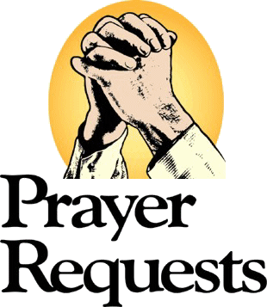

**Wanted! New Members**

The GK has asked each member to bring in at least one new member this year. ASK your friends. “Why aren’t you a member of the Knights of Columbus? ***Share the experience of a lifetime!***

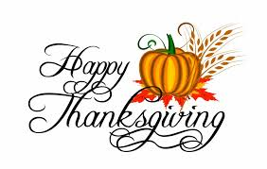

**YOUR COUNCIL REPORTS**

Thanks to all that had paid their dues and made additional donations to the council. If you have not yet paid your

dues they are $50 for regular members and $20 for honorary members. Honorary Life members pay no dues.

Additional donations are greatly appreciated. Make checks payable to KofC 5971. Contact me or one of the officers if you need to make monthly payments. If your mailing address has changed since last year’s billing, please send a change of address to williamgrieco@bellsouth.net. My mailing address is 3934 NW 90th Avenue, Sunrise, FL 33351-8804.

**Archbishop Edward A. McCarthy Assembly**

**4th Degree Edward A. McCarthy Assembly # 3054 next** meeting will be November 21, 2013 at St. John Neumann Council 5971. Also on November 16 we will have our installationof officers followed by a Pot Luck Dinner. The Installation starts at 6:30 PM Member should be there by 6:00PM Dinner to follow Installation. This is a Black Tie affair.

***IMPORTANT MESSAGE FOR ALL 4th DEGREE MEMBER:***

**If there is any Sir Knights that have Regalia and are not using it any more think about donating it to the Council or Assembly. If you have any question or which to make a donations please contact Dennis Sheridan denniss5720@aol.com or call 954-720-2439**

Brothers & Sisters the 119th 200 Club (last of the year) has started. The dinner will be on December 7th, 2013

at the All Saints Family Center. Get your payment early; you can bring your dues to a meeting or please mail

them to Jack at 7863 NW 50th Street, Lauderhill, FL 33351 have them contact Jack at 954-749-0097.

***COME HAVE FUN, JOIN THE 200 CLUB!***

I would like to report that we have a new insurance agent assign to our Council, his name is Danny

Oscariz. For any question please contact him at 305-807-4388 or [Danny.Oscariz@kofc.org](mailto:Danny.Oscariz@kofc.org). Also

you can go to the site [www.insurenaceatyourservice.com](http://www.insurenaceatyourservice.com).

**District Deputy #71**

***No Report***

***No Report***



.

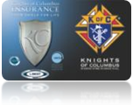

**From Editors Desk**

**Dear brothers, the Holyday season is upon us, and I wanted to ask all of you to help me in making sure that our Council brother are doing ok. Lets us reach out to our missing in action brothers and make sure that they are taking care of. If they are sick let’s make time to visit them if they are in any other type of difficulty let’s extend a helping hand. God Bless.**

***The deadline to submitting information for the newsletter is the 24th of each month. If you wish to publicized a piece, send it to*** [***kianes1@comcast.net***](mailto:kianes1@comcast.net) ***or 954-804-8089***.

**GET YOUR COUNCIL SHIRT**

**Brothers every member of the council should proudly wear a council shirt to the meetings and to any other Knights of Columbus or church activities. Please get in contact with the Worthy Chancellor, Tony Spatola (954-260-8185) to place your order for your 3rd or 4th degree shirts.**

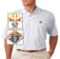

**History Notes;**

[St. John Neumann](http://www.stjohnneumann.org/) Council, it is named after St. John Neumann, who was the Bishop of Philadelphia and the first male Saint of the United States. Born in Prachatitz, Bohemia and after completing theological studies at the University of Prague, he went to New York City in 1836 were he was ordained a priest on June 25 for the Diocese of New York. He was assigned to the Niagara Falls Area on upstate New York to work with recent [German](http://en.wikipedia.org/wiki/German_people) immigrants.

**NO FRIDAYNIGHTERS IN NOVEMBER. HAVE A BLESS THANKSGIVING DAY WITH ALL YOUR LOVE ONES.**



**Grand Knight Notes:** Worthy Honorary Lifetime Members of Council 5971, as the council goes forward on this new Columbian year, I am respectfully asking you to help the council with a donation if possible ($10.00) this will help us as we try to get out monetary issues. My thanks in advance,

*Ed Kianes, GK*

**2013 Mid-Year Organizational Meeting**  
  
**Friday, December 6th through**

**Saturday, December 7**

**Hilton Daytona Beach Oceanfront Resort**  
  
This year’s Mid-Year Organizational Meeting will be held at the Daytona Beach Oceanfront Resort, starting at 6:00 PM on Friday, December 6, and concluding on Saturday, December 7.  Complete Agenda Specifics will be issued shortly, and posted on the State Web Site – along with other Meeting Information – including Details for Meeting and Hotel Registrations.  This will fall under the Icon/Banner, “2013 Mid-Year Meeting”.  (The direct link is [http://floridakofc.org/service/2013-mid-year-meeting](http://cts.vresp.com/c/?FLStateCouncilKofC/0a36d02da7/aab64a13c0/14b6977f71).)  
   
This meeting is mandatory for all State Officers, Directors, Chairmen, and District Deputies.  Please note that Room Reservations must be made by November 22, and that Meeting Registration is a mandatory requirement for reimbursement of Travel and Living Expenses.  (Meeting Organizers will need to know if attendees will be taking guests.  Accordingly, after checking the “I will attend” box, a spousal question will appear, requiring response.)  
  
Please mark your calendars, and check the State Web Site for instructions.

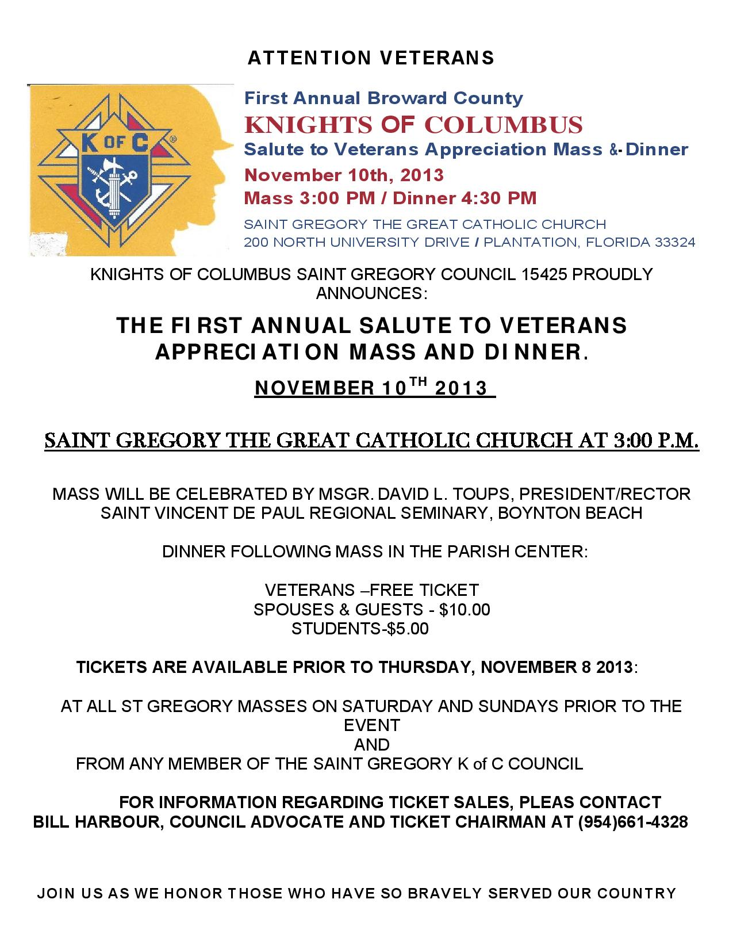

***2013 - 2014 Columbian Year***

***Booster’s time to renew!!***

**SPONSORS**

Alene & Michael Bailey, PGK Paul & Emily Dobrow, Marie & Greg Hawson, Merle & Mary Kay Owens, Ann & Jack Scheckton, PGK Pete & June Becker, James Maguire, Rocco & Eloise Cambareri, Clayton & Lillian Emery, Gus & Laura Hoshbach

*Please renew now. See Sam Arico at the meeting or Send a Check to Sam, c/o 6578 N W 13th Ct., Plantation, FL 33313 4549. Please be a Sponsor & give your $5.00 newsletter booster donation*

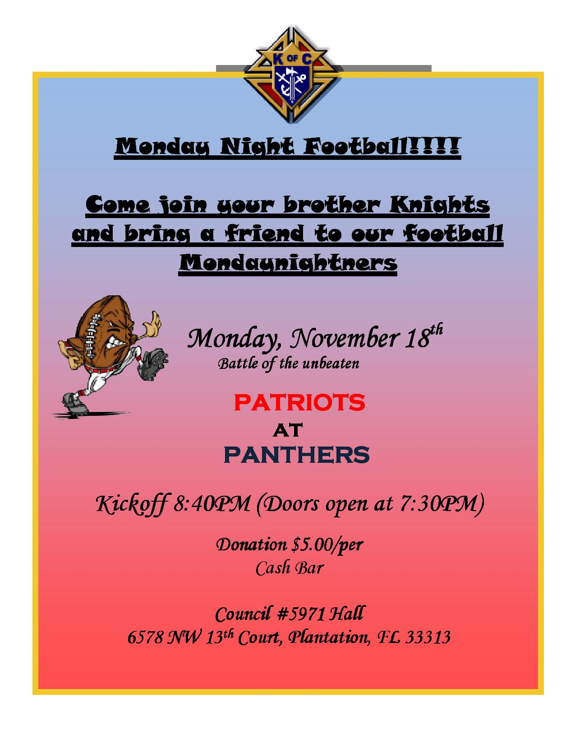

***YOUR COUNCIL OR ASSEMBLY AD COULD BE HERE!***

**CONTACT GK ED KIANES FOR MORE INFO**

**1St & 2nd Degree Exemplification**

**When: Tuesday, November 12**

**Time: 7:00 PM**

**Where: Ascension Catholic Church**

**7250 N Federal Hwy,**

**Boca Raton, FL 33487**

